**A PROJECT REPORT**

**ON**

**CAREER PREDICTION SYSTEM**

Submitted to Jagannath University, Jaipur

In Partial Fulfillment of the requirement for the degree of

**BACHELOR OF COMPUTER APPLICATION**



**JAGANNATH UNIVERSITY**

**Jaipur, (Rajasthan) 302022 BCA(2022-2025)**

**Submitted To: Submitted By:**

Mr. Tulsi Ram Sharma Prince Kumar

Department of Computer Science Jagannath University, Jaipur.

# DECLARATION

I hereby declare that the work, which is being presented in the BCA, Project, entitled **‘Career Prediction System’** in partial fulfillment for the award of Degree of **‘Bachelor of Computer Application’** in Department of Computer Science submitted to the Jagannath University, Jaipur, is a record of my own work carried under the guidance of Mr. Hukum Chand Saini .

I have not submitted the matter presented in this Project Report anywhere for the award of any other Degree.

Submitted To: Submitted By:

Mr. Tulsi Ram Sharma Prince Kumar

(Project Coordinator) Roll No. : 2220035

Sem : VI

Department of Computer Science Jagannath University, Jaipur

# ACKNOWLEDGEMENT

Apart from the efforts of team, the success of any project depends largely on the encouragement and guidelines of many others. We take this opportunity to express our gratitude to the people who have been instrumental in the successful completion of this project. The completion of any inter-disciplinary project depends upon cooperation, co-ordination, and combined efforts of several sources of knowledge.

We are eternally grateful to our guide **Mr. Tulsi Ram Sharma** for her even willingness to give us valuable advice and direction under which we executed this project. Her constant guidance and willingness to share her vast knowledge made us understand this project and its manifestations in great depths and helped us to complete the assigned tasks.

# CERTIFICATE

This is to certify that Major project report entitled "**Career Prediction System**" is the work carried out **Name ……..…………. students of BCA VI Semester, Jagannath University of Jaipur** under the supervision of **………….……….** Assistant Professor, Department of Computer Science, Jagannath University.

This report has not been submitted to any other organization/institution for the award any other Degree/Diploma.

**Mr. Tulsi Ram Sharma**

**(Project Guide)**

|  |  |  |
| --- | --- | --- |
|  | **TABLE OF CONTENTS** |  |
| **S.NO.** | **CONTENTS** | **PAGE NO.** |
| 1. | ABSTRACT | 5 |
| 2. | PROBLEM STATEMENT |  |
| 3. | INTRODUCTION |  |
| 4. | OBJECTIVE |  |
| 5. | SCOPE OF THE PROJECT |  |
| 6. | SYSTEM OVERVIEW |  |
| 7. | TECHNOLOGY STACK |  |
| 8. | QUESTIONNAIRE DESIGN |  |
| 9. | LOGIC AND FLOW DESIGN |  |
| 10. | USER INTERFACE DESIGN |  |
| 11. | SYSTEM ARCHITECTURE |  |
| 12. | RESULT ANALYSIS |  |
| 14. | CHALLENGES FACED |  |
| 15. | LIMITATION OF THE SYSTEM |  |
| 16. | FUTURE ENHANCEMENT |  |
| 17. | CONCLUSION |  |
| 18. | REFRENCES |  |
| 19. | APPENDIX |  |

# ABSTRACT

Career selection is one of the most crucial decisions in a person's life, often influenced by personal interests, skills, and goals. However, many individuals—especially students—struggle to identify a suitable career path due to a lack of self-awareness or structured guidance. To address this challenge, this project presents a Career Prediction System developed using core JavaScript functionalities. The system asks users a series of thoughtfully designed questions that assess their interests, preferences, and aptitudes. Based on the user’s responses, the program applies predefined logic and conditions to evaluate and recommend the most suitable career options.

Unlike AI-based models that rely on complex algorithms and large datasets, this system operates on deterministic logic implemented entirely in JavaScript, making it lightweight, efficient, and easy to deploy on web platforms. The goal is to offer a fast, accessible, a nd user-friendly career recommendation tool for individuals seeking initial guidance without relying on machine learning or external APIs. This report details the system's design, logic structure, implementation approach, and potential use cases in educational or personal career planning contexts.

# PROBLEM STATEMENT

In today’s competitive world, students and early-stage professionals are often faced with the daunting task of choosing a career path that aligns with their interests, strengths, and long-term goals. Unfortunately, many individuals lack access to effective career counseling or structured tools that can assist them in making informed decisions. This often leads to confusion, trial-and-error choices, dissatisfaction in professional life, and wasted resources such as time, effort, and educational investment.

Traditional career guidance methods—such as in-person counseling or general aptitude tests—can be time- consuming, inconsistent, or inaccessible to many. There is a need for a simple, interactive, and easy-to-use solution that can provide immediate and personalized career suggestions based on user inputs.

The challenge lies in creating a lightweight, client-side system that does not rely on artificial intelligence or complex algorithms but still offers relevant and useful guidance. Therefore, this project aims to develop a **rule-based Career Prediction System using JavaScript** that guides users toward suitable career options by analyzing their responses to a set of predefined questions.

# INTRODUCTION

Choosing the right career is a vital step in shaping an individual's future, yet it remains one of the most challenging decisions for students and young professionals. Many people find themselves unsure about which field best suits their interests, strengths, and long-term goals. In the absence of proper guidance, this uncertainty can lead to poor career choices, dissatisfaction, and wasted time and resources.

To address this problem, the Career Prediction System has been developed as a simple, web- based solution that helps users identify potential career paths based on their personal preferences and responses to a series of structured questions. Unlike complex artificial intelligence models, this system relies on JavaScript-based logic, making it lightweight, easy to understand, and efficient for quick decision-making.

The system uses a rule-based approach where each user response contributes to a score or pathway that aligns with specific career options. By evaluating responses in real-time, the system generates relevant recommendations tailored to the user's interests and aptitudes. This approach ensures fast processing, minimal resource requirements, and a high degree of customization.

This report explores the design, logic, and development process of the system, with a focus on user experience, decision flow, and practical implementation using HTML, CSS, and JavaScript. The system is particularly beneficial for educational institutions, counselors, and individuals looking for an accessible and technology-driven way to receive career guidance.

# OBJECTIVE

The primary objective of this project is to develop a comprehensive and interactive **Career Prediction System** that aims to assist users—particularly students, fresh graduates, and individuals facing uncertainty in their professional journey—in identifying the most appropriate and fulfilling career paths based on their unique preferences, interests, skills, and mindset. The system functions by guiding users through a structured questionnaire, which has been carefully designed to extract meaningful insights about their personality traits, academic inclinations, working styles, and general career aspirations.

Rather than utilizing complex artificial intelligence algorithms or advanced machine learning models, this project deliberately focuses on a **client-side implementation using core JavaScript** to ensure simplicity, transparency, and efficiency. All logic for interpreting user responses, calculating scores, and mapping them to suitable career options is handled directly within the browser using condition-based rules and scoring mechanisms. This design choice allows the system to operate independently without depending on third- party APIs, server-side databases, or external libraries, which makes it extremely lightweight, easily deployable, and highly accessible to a broad range of users regardless of their technical environment.

The ultimate goal of this system is to provide a **reliable, fast, and user-friendly web-based tool** that delivers accurate and relevant career suggestions in real time. It is designed to be intuitive enough for first- time users while offering meaningful outcomes that can serve as a valuable first step toward career exploration. By focusing on a rule-based prediction approach, the system ensures that every decision is explainable and logically sound, helping users understand the rationale behind the recommendations.

Additionally, the tool is built with accessibility and simplicity in mind, making it easy to integrate into educational institutions, personal career websites, or online self-assessment platforms.

## Objectives:

1. **To design a comprehensive and structured questionnaire**

The system aims to feature a thoughtfully designed set of questions that cover a wide range of factors influencing career decisions, including personal interests, cognitive preferences, behavioral tendencies, learning styles, academic strengths, and social inclinations. Each question is carefully worded to gather qualitative and quantitative input from users, making the data more meaningful for evaluation.

The structure of the questionnaire is modular, allowing questions to be grouped into categories and scored accordingly for more accurate prediction outcomes.

## To implement a rule-based decision-making mechanism using JavaScript

The system uses pure JavaScript logic to create an intelligent decision-making process that evaluates user responses based on predefined rules, weightages, and scoring conditions. Each answer contributes to a cumulative score that aligns with different career profiles.

By using nested conditionals, functions, and control structures, the system mimics the behavior of

expert systems—generating relevant career suggestions without requiring AI or machine learning algorithms. This ensures transparency in how decisions are made and allows for easy debugging and future logic modification.

## To generate instant and personalized career recommendations

One of the key objectives is to provide users with career suggestions in real time, immediately after completing the questionnaire. The recommendation process is entirely client-side, requiring no backend or server interaction, which ensures fast performance and a smooth user experience.

The system presents clear, meaningful output that includes the predicted career path(s), along with a brief description or justification to help the user understand why those careers are suitable for them.

## To develop a lightweight, responsive, and fully browser-compatible solution

The entire system is designed to run on any modern web browser, ensuring that it works across desktops, laptops, tablets, and mobile devices without requiring installations or special configurations. The use of HTML, CSS, and JavaScript ensures platform independence and ease of deployment.

The focus is on clean design, responsive layouts, and accessible navigation, making the system suitable for users of varying age groups and technical backgrounds. Because there are no external libraries or heavy frameworks, the application remains lightweight and easy to host or embed in other platforms.

## To build a flexible and extensible framework for future expansion

A major objective is to ensure that the logic and structure of the system are modular and adaptable. As career fields evolve and user needs grow, the system should allow the addition of new questions, scoring rules, and career categories without the need for a complete redesign. This objective ensures long-term usability and future-proofing.

It also opens up the possibility of eventually integrating more advanced features, such as database support, user history tracking, or even optional AI modules in later versions.

## To offer meaningful guidance to students and career seekers in a self-directed format

The ultimate purpose of this system is to empower users—particularly those who lack access to professional counseling or mentorship—with a tool that helps them begin their career exploration journey. The system acts as a virtual advisor, helping users understand their strengths and preferences, and pointing them toward potential career paths worth exploring. While not a replacement for professional guidance, it serves as an effective first step in the decision-making process, encouraging users to research and reflect further on the careers suggested.

# SCOPE OF THE PROJECT

The scope of this project encompasses the design, development, and deployment of a browser-based **Career Prediction System** that provides users with suitable career suggestions based on their responses to a predefined set of questions. This system is intended to serve as an accessible and self-guided tool for career assessment, particularly targeting students, fresh graduates, and individuals who are at a point in life where making a career decision is critical but professional guidance is not easily available.

At its core, the project is built entirely using **frontend web technologies**, specifically **HTML**, **CSS**, and **JavaScript**, with no requirement for server-side programming, databases, or artificial intelligence algorithms. This makes the application extremely lightweight, easy to deploy on any static web server, and accessible from virtually any modern web browser across multiple devices such as desktops, laptops, tablets, or smartphones. Because it runs completely on the client side, it requires no internet connection after initial loading, which further extends its usability in low-connectivity areas.

The system is based on a **rule-based logic model**, where each user’s response contributes to a calculated score or logical path that is mapped to specific career recommendations. This approach ensures that the decision-making process is fully transparent, easy to understand, and modifiable. The scope also includes the development of a user-friendly graphical interface that guides users through the questionnaire, provides instant feedback, and displays results in an intuitive and engaging manner.

This project has significant practical value and can be deployed in a variety of **real-world scenarios** to support individuals in making informed career decisions. Its simplicity, accessibility, and adaptability make it suitable for use across diverse environments where career guidance is essential but not always readily available. Below are some key areas where the Career Prediction System can be effectively implemented:

## Educational Institutions

Schools, colleges, and coaching centers can integrate this system into their academic counseling programs to help students identify their strengths and career interests before choosing their academic streams or subjects. For example, high school students can use the system to get guidance on whether they are better suited for fields like science, commerce, arts, or vocational training based on their aptitude and interests. It can also help college students explore specific career options within their chosen field.

## Career Counseling Workshops

In career development sessions and workshops, this system can serve as a **supplementary tool** for counselors and facilitators. Before a one-on-one counseling session, participants can use the tool to generate preliminary career suggestions. These results can then be used as a base for further discussion and deeper evaluation, thereby saving time and making sessions more productive and data-driven.

## Self-Assessment Websites

Many individuals today prefer to explore career guidance tools online. This system can be embedded on **self-help or career guidance websites** to offer visitors a quick, interactive way to assess their

career fit. Since it is fully browser-based and requires no login or server interaction, users can get immediate results, making it ideal for personal exploration, especially for those who may not be comfortable with formal counseling settings.

## Personal Development Platforms

Online platforms that promote personal growth, skill-building, or life planning can include this system as an **add-on feature**. It can be bundled with resources such as resume builders, interview preparation tools, or e-learning platforms to provide a holistic career development experience. Users engaging in upskilling or reskilling can use the tool to re-evaluate their career direction based on new interests or competencies.

Additionally, the project has been designed with **future scalability in mind**. Although the current version is purely JavaScript-based, it can be extended in the future to include features such as user login, result history storage, backend integration, or even AI/ML models for more complex predictions. More questions, career categories, or domain-specific recommendations can also be added without modifying the core logic significantly.

# SYSTEM OVERVIEW

The **Career Prediction System** is a web-based application designed to help users, particularly students and young professionals, identify suitable career paths based on their preferences, interests, and personality traits. The system operates entirely on the client-side, using standard web technologies such as **HTML**, **CSS**, and **JavaScript**, ensuring high accessibility, performance, and ease of use without requiring backend servers, databases, or artificial intelligence models.

At its core, the system presents users with a structured and intuitive questionnaire consisting of multiple- choice and scenario-based questions. These questions are carefully curated to evaluate the user’s strengths, interests, learning styles, and general behavior in various contexts. As the user progresses through the questionnaire, their responses are internally processed using conditional logic and scoring mechanisms written in JavaScript.

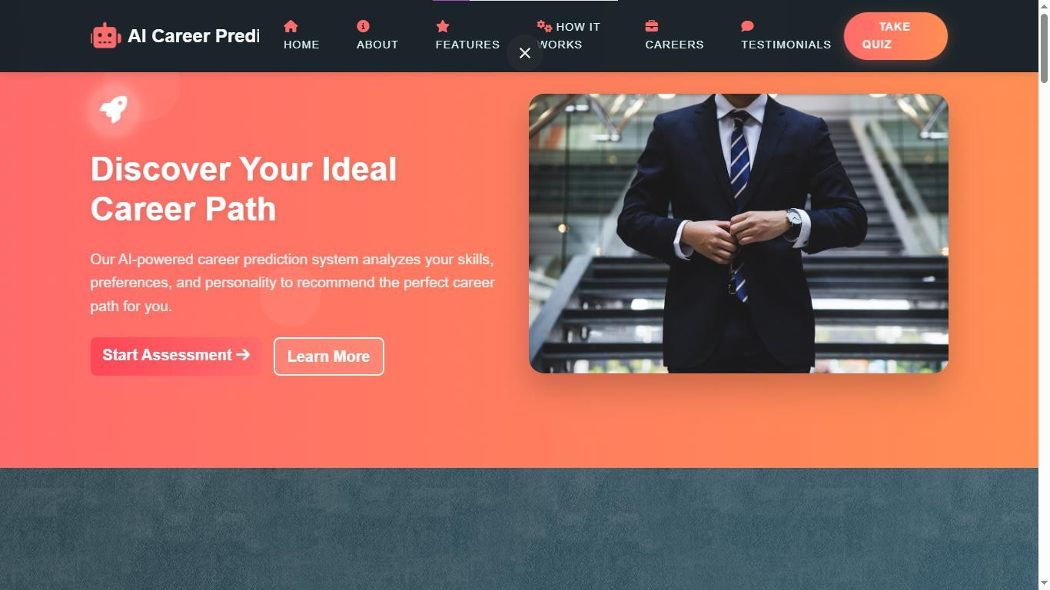

The system follows a **rule-based decision-making model.** Each response is assigned specific points or values, which are then used to calculate a final score profile. Based on this profile, the system matches the user to a set of predefined career categories. These career paths are mapped to specific score ranges and logical conditions that reflect the user’s potential compatibility with certain fields (e.g., Engineering, Arts, Business, Teaching, Medical, Design, etc.). Once the evaluation is complete, the system generates a result page that displays one or more suitable career suggestions, along with short descriptions or explanations for each option to guide the user further.

The **user interface** is designed to be clean, responsive, and easy to navigate. It includes a landing page, questionnaire pages, and a results page, all styled using CSS to provide a visually appealing and smooth user experience. Users can complete the entire process in a few minutes, and since no internet connection is required after loading the page, it is ideal for both urban and remote environments.

This system is not only useful for immediate self-assessment but is also scalable for use in larger environments such as schools, career fairs, and online education portals. The codebase is modular and organized in a way that allows easy modification of questions, logic, or career outcomes, making the system highly adaptable for future expansions or customizations.

# TECHNOLOGY STACK

The **Career Prediction System** is designed using a simple yet powerful set of client-side web technologies. The entire application runs in the user's browser, eliminating the need for server-side processing, databases, or external APIs. This lightweight architecture makes it ideal for fast deployment, cross-platform compatibility, and offline usability. Below is a breakdown of the core technologies used in the development of the system:

## HTML (HyperText Markup Language) Purpose:

Structure & Layout

HTML forms the foundation of the Career Prediction System. It is used to create and organize the structure of the web pages. All key elements of the application—including the home page, questionnaire, form inputs, buttons, and result sections—are built using HTML tags. Semantic HTML5 tags like <section>, <article>,

<form>, and <button> ensure that the content is properly organized, accessible, and SEO-friendly.

## Key Contributions:

* + Creates the layout of the question form.
  + Holds the navigation structure and interactive elements.
  + Displays career results dynamically using DOM manipulation.

## CSS (Cascading Style Sheets) Purpose:

Styling & Presentation

CSS is used to enhance the visual design and layout of the application. It ensures that the user interface is clean, responsive, and consistent across all devices and screen sizes. Custom CSS stylesheets are written to style buttons, inputs, text areas, containers, and the results display section. Media queries and flexible units like percentages or viewport widths are used to ensure responsiveness on mobile phones, tablets, and desktops.

## Key Contributions:

* + Provides modern and user-friendly UI/UX.
  + Implements responsive design for multi-device support.
  + Adds visual feedback (e.g., hover effects, transitions) to improve user interaction.

## JavaScript

**Purpose:**

Logic, Interactivity & Processing

JavaScript is the heart of the Career Prediction System. It is responsible for all interactivity and decision- making processes in the system. The script collects user responses in real-time, calculates scores based on pre-defined conditions, and dynamically displays the final career recommendations. JavaScript functions manage control flow, event handling (such as button clicks), and DOM manipulation to make the experience smooth and responsive.

## Key Contributions:

* + Handles user input and validates form interactions.
  + Implements rule-based scoring logic to evaluate responses.
  + Dynamically generates and displays results without page reloads.
  + Ensures the system works without any server or AI backend.

## DOM (Document Object Model) Manipulation Purpose:

Dynamic Content Rendering

JavaScript interacts with the DOM to update the webpage in real time. As users answer questions, the DOM is manipulated to show or hide questions, highlight selections, and eventually display the prediction result. This technique helps avoid page reloads and provides a fluid user experience.

## Key Contributions:

* + Dynamically updates the question flow.
  + Renders result sections based on user interaction.
  + Provides instant feedback to the user.

## Bootstrap – Faster UI Development Purpose

To quickly build a responsive and modern user interface using pre-built components and a powerful grid system.

## Explanation

Bootstrap is a popular front-end framework that has been used in this project to streamline the design and

development of the user interface. It provides a comprehensive collection of CSS and JavaScript components such as buttons, forms, modals, alerts, and a responsive grid layout that work seamlessly across all modern browsers and devices.

## Benefits in This Project:

* **Responsive Design** : The system adjusts its layout automatically for desktops, tablets, and mobile devices.
* **Predefined Components**: Forms, buttons, and alerts were implemented with minimal custom styling.
* **Consistent Styling**: Ensures visual consistency across all UI elements without writing much CSS.
* **Grid System**: Helped structure the layout of the questionnaire and result sections effectively.

Using Bootstrap allowed for rapid UI development, improved user experience, and reduced the time required to achieve a professional, polished appearance.

## LocalStorage – Temporary User Data Storage Purpose:

To store user responses and result data directly in the browser during a session, without the need for a backend database.

## Explanation:

The LocalStorage API was used to temporarily hold user data such as their answers to questions and the generated career prediction result. LocalStorage is part of the Web Storage API and allows key-value pair data to be stored locally within the user's browser with no expiration time.

## Benefits in This Project:

* **Data Persistence** : Saved data remains even if the user refreshes the page or reopens the browser.
* **Session Continuity** : Users can resume where they left off if they accidentally close or refresh the page.
* **No Backend Needed** : Eliminates the need for server-side storage or a database, keeping the system lightweight.
* **Improved UX**: Allows for features like result history or auto-filled inputs on returning visits.

LocalStorage ensures a smooth, uninterrupted user experience by maintaining data on the client side while preserving the simplicity and speed of a static web application.

# QUESTIONNAIRE DESIGN

The **questionnaire** serves as one of the most crucial components of the **Career Prediction System**, as it plays a direct and significant role in influencing the career recommendations that are ultimately generated for the user. The structure and design of the questionnaire have been meticulously planned and carefully crafted to ensure that it captures the most important aspects of the user's personality, interests, preferences, and aptitudes. These factors are essential in making accurate, relevant, and personalized career suggestions that align with the user's unique characteristics.

By taking into account a wide range of variables, from personal interests to learning styles, the questionnaire serves as a valuable tool in identifying the most suitable career paths for individuals.

The design process was driven by the need for simplicity, engagement, and effectiveness in gathering data, and it has been optimized for both clarity and ease of use. Below, we provide a detailed and comprehensive overview of the structure, layout, and functionality of the questionnaire, highlighting how it efficiently captures the key data needed for accurate career predictions.

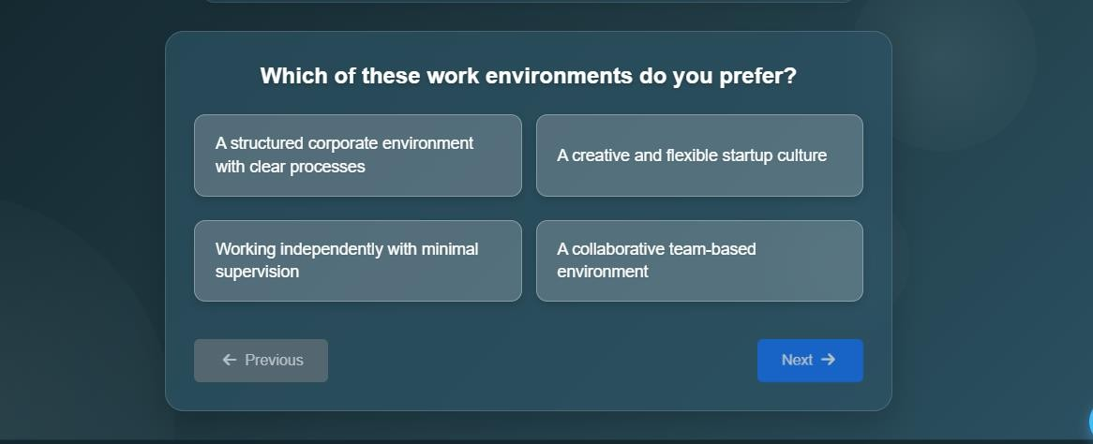

## Questionnaire Structure

The questionnaire is structured to consist of a series of **multiple-choice questions** and **scenario-based questions**, each targeting a different aspect of the user's traits, preferences, and goals. The questions are designed to be simple, straightforward, and engaging, ensuring that users can easily understand and answer them. The flow of the questionnaire follows a logical order, with questions progressively delving deeper into various career-related factors.

## Key Categories:

* + **Personal Interests**: Questions to understand the user’s general interests, such as preferred activities or hobbies.
  + **Skills and Strengths**: Assesses the user's skills and self-perceived strengths (e.g., analytical skills, creativity, leadership).
  + **Learning Style**: Questions to determine the user’s preferred learning method (visual, auditory, kinesthetic, etc.).
  + **Personality Traits**: Focuses on behavioral traits such as introversion vs. extroversion, decision- making style, etc.
  + **Career Aspirations**: Explores the user’s ambitions, such as desired work-life balance, income expectations, and job stability preferences.
  + ​

## Question Types

To capture a variety of factors related to career decisions, the questionnaire incorporates a mix of question types:

* + **Multiple-Choice Questions (MCQs)**: These are the most common type of questions, where the user selects one answer from a list of options. For example:
    - "Which of the following activities do you enjoy the most?"
      * A) Solving complex problems
      * B) Helping people
      * C) Designing things
      * D) Managing teams
  + **Likert Scale Questions**: These assess the degree to which the user agrees or disagrees with statements (e.g., “I enjoy working in teams”).
    - “I prefer working in a team rather than working alone.”
      * Strongly Agree / Agree / Neutral / Disagree / Strongly Disagree
  + **Scenario-Based Questions**: These questions present real-world scenarios and ask users to choose how they would respond. For example:
    - "You are given a challenging project at work. What is your approach?"
      * A) Plan carefully and follow a structured approach
      * B) Start working on it immediately and figure things out as you go
      * C) Ask others for help and collaborate on solving the problem
      * D) Break down the project into smaller tasks and tackle them one at a time

## Scoring Mechanism

Each answer choice in the questionnaire is associated with a **predefined score**. The scores represent different personality traits or aptitudes that are mapped to specific career paths. As users progress through the questionnaire, their responses are used to accumulate scores that reflect their strengths, interests, and tendencies.

For example:

* + If a user answers more questions indicating an interest in **problem-solving**, they might accumulate points that are later linked to careers in **engineering** or **software development**.
  + If a user consistently indicates a preference for **helping others**, they might receive a higher score in fields like **healthcare** or **social work**.

Once the questionnaire is completed, the accumulated scores are used to suggest the most suitable career paths based on predefined rules, with the highest-scoring careers being recommended to the user.

## User Experience (UX) Considerations

The design of the questionnaire takes into account the **user experience** to ensure a smooth and engaging process:

* + **Progress Indicator**: A progress bar or step indicator shows users how far along they are in the questionnaire, keeping them informed and motivated.
  + **Clear Instructions**: Simple and concise instructions are provided at the beginning of the questionnaire and for each section to ensure users understand what is expected of them.
  + **Responsive Design**: The questionnaire adjusts its layout to fit all screen sizes, ensuring users can complete it easily on any device, whether desktop, tablet, or smartphone.
  + **Time Efficiency**: The questionnaire is designed to be completed in under 10 minutes, ensuring users can quickly get results without feeling overwhelmed.

## Data Collection and Processing

Once the user completes the questionnaire, their responses are collected in real time using **JavaScript** and processed to generate career recommendations. This data is temporarily stored in the **LocalStorage** to preserve the user's progress and results.

The final results are displayed immediately, providing users with insights into their strengths and potential career paths.

## Flexibility and Scalability

The questionnaire is designed to be **modular**, allowing for easy updates and additions. New questions or categories can be added without disrupting the flow of the questionnaire. Additionally, the system allows for customization, meaning specific questions or career paths can be tailored to different audiences, such as students from different educational backgrounds or professionals looking to change careers.

# LOGIC AND FLOW DESIGN

The **Career Prediction System** is designed to offer personalized career suggestions based on the user’s responses to a series of structured questions. The system’s logic follows a clear and intuitive flow, ensuring that the entire process is seamless, efficient, and provides accurate results in real-time. Below is a detailed explanation of the core logic behind the system and how the flow of data operates:

## User Input: Questionnaire Interaction

The process begins with the user interacting with the **questionnaire**. The user is presented with a series of multiple-choice questions designed to assess various aspects of their personality, interests, and skills. These questions are divided into different categories, such as:

* + **Personal Interests**
  + **Skills & Strengths**
  + **Learning Style**
  + **Career Aspirations**
  + **Personality Traits**

Each question has pre-defined answer options that are mapped to specific values or scores. These responses are stored temporarily using **LocalStorage** to preserve the user's answers during the session, ensuring that the user can navigate through the questionnaire without losing data.

## Data Collection and Processing

As the user answers the questions, their choices are **captured** and **stored** in **LocalStorage** in the form of key-value pairs. This data is collected in real-time and can be accessed later for generating career recommendations.

The data gathered in this stage includes:

* + **User responses** to each question.
  + **Calculated scores** based on predefined rules linked to each response.

For example:

* + If the user chooses "Problem-solving" as their interest, they might receive points associated with

## engineering or software development.

* + If the user indicates that they prefer "helping others," this might contribute to career paths in

## healthcare, social services, or counseling.

1. **Score Calculation**

After the user has completed the questionnaire, the collected responses are processed and scored based on predefined weights. Each answer option is assigned a score reflecting its alignment with different career paths. For example:

* + Answering "I enjoy solving complex problems" could be linked with a higher score for analytical fields like **software engineering** or **research**.
  + Choosing "I like working with people" could increase the likelihood of a match for careers in **sales**, **teaching**, or **medicine**.

The **scoring mechanism** is **rule-based**, where each possible response carries a certain weight that contributes to the final result. Based on the accumulated scores, the system will rank possible career suggestions, starting with the most suitable career based on the user's responses.

## Real-Time Career Prediction

Once the user has completed the questionnaire and their responses have been processed, the system evaluates the accumulated scores and generates a set of career recommendations. These recommendations are based on which career paths have the highest scores.

The flow of data in this phase includes:

* + **Calculation of accumulated scores** based on the user’s answers.
  + **Mapping scores** to relevant career paths from a predefined list.
  + **Presentation of results**: The user is shown a list of the most suitable career options, ordered by the highest score.

## User Experience (UX) Design

The design of the system ensures a smooth and user-friendly experience. Throughout the process, the user is guided by:

* + **Progress Indicators**: A visual indicator (e.g., a progress bar) shows the user how much of the questionnaire they’ve completed and how much is left.
  + **Clear Instructions**: Each question is displayed clearly with easy-to-understand instructions, ensuring that the user knows exactly what to do.
  + **Immediate Results**: Once the user finishes the questionnaire, the results are displayed instantly, making the system responsive and efficient.

## Data Storage and Session Management

To enhance the user experience and allow the user to revisit or review their responses, **LocalStorage** is used. This enables the system to:

* + Temporarily store answers and scores without requiring backend storage.
  + Retain user data for the duration of the session, even if the page is refreshed or the user navigates away from the questionnaire.

This also means that the system is **client-side** and **lightweight**, without relying on external servers or databases, ensuring faster load times and improved performance.

## Flow Diagram of the System

To better visualize the flow of data and logic in the Career Prediction System, here is a simple flow diagram:

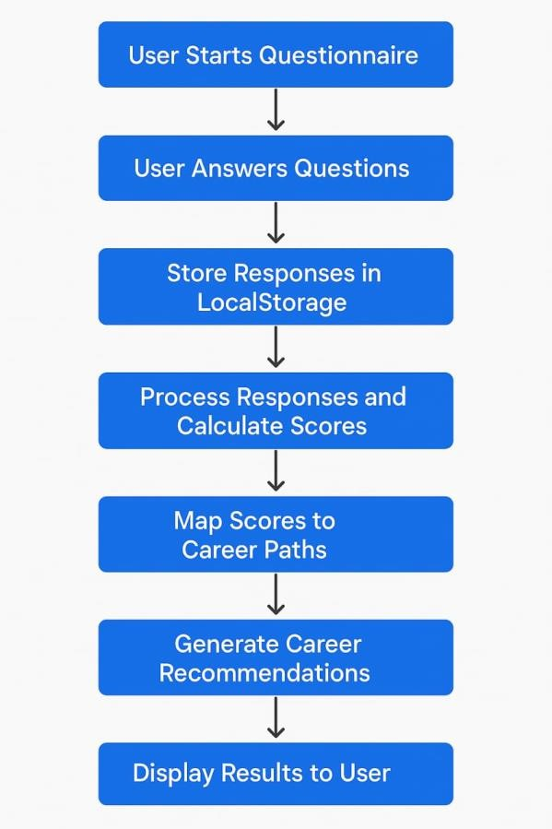

This step-by-step flow ensures that the user is guided through a seamless process, leading to personalized and actionable career suggestions.

# USER INTERFACE DESIGN

The **User Interface (UI)** of the **Career Prediction System** has been meticulously crafted with a primary focus on **simplicity**, **ease of use**, and **aesthetically pleasing design**, ensuring that users from all backgrounds—especially students and career seekers—can effortlessly navigate through the platform without confusion or frustration. The interface is structured in a way that allows even first-time users to clearly understand how to interact with the system and make full use of its features. Special attention has been given to **layout clarity**, **intuitive button placement**, and **interactive responsiveness**, allowing users to move smoothly from one stage of the process to another without interruptions.

The overall design adopts a **user-centric approach**, meaning that every visual and functional element has been implemented with the end user’s experience in mind. Whether a user is technologically proficient or someone new to using digital tools for career planning, the interface aims to be as **inclusive, accessible, and engaging** as possible. It ensures an uninterrupted, focused, and enjoyable journey from the moment the user lands on the homepage to the final display of career suggestions.

By combining **functional efficiency** with **clean visual aesthetics**, the UI not only enhances user satisfaction but also reinforces the credibility and usefulness of the system itself. The design encourages interaction, reduces the learning curve, and guides the user through the questionnaire and results in a seamless flow.

Below is a comprehensive breakdown of the key elements and considerations involved in the design and development of the user interface.

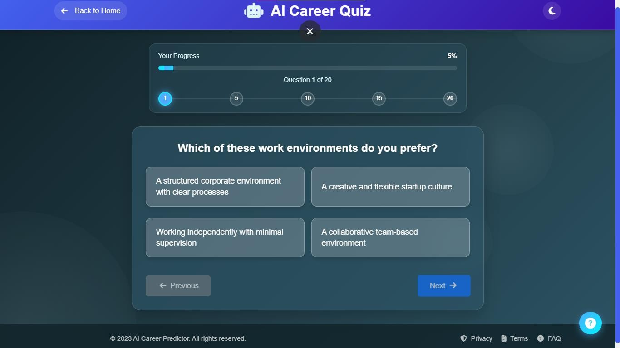

## Overall Design Philosophy

The design philosophy of the Career Prediction System is based on the principle of **minimalism** and **clarity**. The goal is to provide a clean and intuitive layout that makes the user experience as straightforward as possible. The UI is designed to be visually appealing while maintaining functionality. The key design principles applied include:

* + **Simplicity**: Avoid unnecessary complexity in the design, ensuring that the user can focus on answering questions and getting results.
  + **Consistency**: Consistent styling across all pages and elements, including colors, fonts, and spacing, creates a cohesive experience.
  + **Responsiveness**: The UI adjusts to different screen sizes (desktop, tablet, mobile) to ensure a seamless experience on any device.
  + **Accessibility**: The design takes into consideration accessibility features, such as readable fonts and clear button labels, to ensure the platform is usable by everyone.

## UI Components and Layout

The UI is organized into several key sections, each with distinct functionalities. Below is an overview of the key components and their purpose:

## Home Page (Landing Page)

The home page is designed to introduce users to the Career Prediction System, with a clean layout and engaging visuals. It includes:

* + **Welcome message** and **Brief Introduction** to explain the purpose of the system.
  + **Start Button** that directs users to the questionnaire section.
  + **Call-to-Action (CTA)** to encourage users to proceed with the career assessment.

The design uses **large buttons** and **clear text** to ensure that the page is easy to navigate, even for first-time users.

## Questionnaire Page

This is the most crucial part of the system where users interact with the questions. The page is designed to be user-friendly and responsive, with the following features:

* + **Multiple Choice Questions**: Users are presented with questions and a set of pre-defined answer choices.
  + **Progress Bar**: A progress bar at the top shows users how far they are in the questionnaire, reducing anxiety and helping them understand the remaining steps.
  + **Responsive Layout**: The page layout adjusts to different screen sizes to maintain accessibility across devices (desktop, tablet, mobile).
  + **Clear Instructions**: Each question is accompanied by brief instructions or descriptions to ensure users understand what they are being asked.
  + **Previous and Next Buttons**: These buttons allow users to navigate through the questionnaire, with the option to go back and change previous answers.

## Results Page

Once the user completes the questionnaire, the system generates career recommendations based on the answers. The **results page** is designed to be informative, clear, and visually appealing:

* + **Career Suggestions**: The results are presented in the form of a **list** of careers, sorted by the most suitable options based on the user’s responses.
  + **Detailed Career Descriptions**: Each career suggestion is accompanied by a brief description that explains why it is a good match for the user.
  + **Score Breakdown**: Users can view a summary of how their responses contributed to the career suggestions (e.g., areas such as skills, interests, etc.).
  + **Call-to-Action**: The results page includes a CTA button, such as "Explore More Careers" or "Take the Test Again," allowing users to either learn more or retake the test for different insights.

## Footer

The footer of the site is consistent across all pages and includes:

* + **About**: A brief section about the Career Prediction System and its purpose.
  + **Contact**: Links to contact information or a feedback form.
  + **Privacy Policy**: Ensures users are aware of how their data is handled.

## UI Styling and Aesthetics

The **styling** of the Career Prediction System is kept clean and modern, using visually appealing colors, typography, and layouts. The primary focus is on readability and ease of interaction. The UI uses:

* + **Color Scheme**: A professional yet engaging color palette with contrasting colors for important buttons and sections. For example, the background might be light, with buttons and highlights in a bright color like blue or green to attract attention.
  + **Typography**: A clear and legible font is used for all text elements, ensuring that the content is easy to read across all devices.
  + **Spacing and Alignment**: Proper spacing and alignment are used to make the content organized and prevent clutter, ensuring a smooth visual flow throughout the page.
  + **Iconography**: Simple, intuitive icons are used for buttons or sections like “Next” and “Previous,” improving usability and engagement.

## Bootstrap Integration for Responsive Design

The Career Prediction System uses **Bootstrap** for responsive design, ensuring that the application functions smoothly across different devices, including desktop, tablet, and mobile. With Bootstrap, the design elements automatically adjust their layout and size to fit the screen, providing a consistent and optimized user experience.

Key features of Bootstrap utilized in the design include:

* + **Grid System**: The layout is structured using Bootstrap’s grid system, allowing for responsive columns and components that adjust based on the screen size.
  + **Predefined Components**: Bootstrap provides pre-designed components such as buttons, form elements, and navigation bars, speeding up development and ensuring consistency across the system.
  + **Flexbox Utilities**: These utilities are used to center content, align elements, and create flexible layouts, making the UI more adaptable and responsive.

## User Flow and Interaction Design

The user flow of the system is designed to be as smooth and intuitive as possible. Users will follow a simple step-by-step process:

1. **Introduction**: User lands on the homepage and clicks “Start”.
2. **Questionnaire**: User proceeds through the questionnaire, answering questions about their preferences, skills, and personality.
3. **Real-Time Processing**: After completing the questionnaire, the system calculates the career suggestions in real-time and presents them.
4. **Results**: The user is presented with a list of career suggestions along with their relevant scores and career descriptions.

## Accessibility Considerations

The Career Prediction System takes into account accessibility requirements to ensure it is usable by all users, including those with disabilities. Some accessibility features include:

* + **Keyboard Navigation**: The system can be navigated using only the keyboard, making it accessible to users who cannot use a mouse.
  + **Screen Reader Compatibility**: Proper semantic HTML is used to ensure that the system is compatible with screen readers for visually impaired users.

• **Color Contrast**: Colors are chosen to provide sufficient contrast, making text easy to read for users

# SYSTEM ARCHITECTURE

The **System Architecture** of the Career Prediction System represents the overall structure and functioning of various components that work together to deliver a smooth, interactive, and efficient user experience.

Since the system is built using **client-side technologies** such as **HTML, CSS (Bootstrap), and JavaScript**, it is primarily a **front-end-only, browser-based application**. This lightweight architecture ensures fast loading times, minimal resource usage, and ease of deployment without the need for complex backend infrastructure or server-based processing.

## Client-Side Processing Model

The system adopts a **client-side processing architecture**, meaning all operations—from data collection and storage to processing and result display—occur within the user's browser. This approach removes the dependency on external servers or databases, making the application faster and easier to access, even with limited internet connectivity.

Key benefits of this architecture include:

* + Instant feedback and real-time processing
  + No need for user authentication or server setup
  + Easy deployment on platforms like GitHub Pages
  + Enhanced privacy since user data is not sent to any server

## Component-Based Structure

The Career Prediction System is logically divided into multiple components, each responsible for a specific task within the application:

## User Interface Layer (HTML + Bootstrap)

* + Responsible for presenting the visual content to the user.
  + Built using **HTML** for structure and **Bootstrap** for responsive design and styling.
  + Includes sections such as the homepage, questionnaire form, and result display area.
  + Ensures mobile and desktop responsiveness using Bootstrap’s grid system.

## Logic Layer (JavaScript)

* + Handles the application's core functionality.
  + Responsible for:
    - Capturing user responses
    - Performing calculations or logic checks based on answers

o Determining the most suitable career suggestions

* + - Dynamically generating and updating the result page
  + Encapsulates all rules and logic required for processing the input.

## Data Handling Layer (LocalStorage)

* + Utilizes **Web Storage API (LocalStorage)** to temporarily store user inputs during a session.
  + Ensures that data remains available even if the user accidentally refreshes the page.
  + Acts as a simple, session-aware storage mechanism to support stateless architecture.

## Workflow and Data Flow

The system follows a linear workflow pattern, which consists of the following steps:

## User Accesses the Application

The user opens the career prediction web app on their browser.

## Questionnaire Interaction

The user proceeds to answer a set of carefully designed multiple-choice questions based on personality, interests, and skills.

## Local Data Storage

User responses are captured and stored temporarily using LocalStorage for easy retrieval and processing.

## Logic Execution

JavaScript processes the stored responses using predefined logical conditions, scoring mechanisms, or category mapping.

## Career Mapping

Based on the scores or answer patterns, the system maps the user’s profile to the most suitable career paths.

## Result Display

Final career recommendations are dynamically displayed to the user along with supportive explanations.

## Technology Stack Integration

|  |  |  |
| --- | --- | --- |
| **Layer** | **Technology Used** | **Purpose** |
| **Presentation Layer** | HTML + Bootstrap | To create and style the user interface |
| **Logic Layer** | JavaScript | To process user input, evaluate logic, and display results |
| **Data Storage Layer** | LocalStorage | To store user data temporarily within the session |

1. **Deployment Architecture**

Since the entire system is built using front-end technologies, it can be deployed as a **static website** without needing a backend server. Tools like **GitHub Pages** or **Netlify** are ideal for hosting this application.

Deployment only requires uploading the HTML, CSS, and JavaScript files, which makes it lightweight, fast, and easy to maintain.

# RESULT ANALYSIS

The **Result Analysis** section of the Career Prediction System focuses on how user responses are interpreted, processed, and translated into meaningful career recommendations. Since this system does not use any artificial intelligence or machine learning algorithms, the results are based entirely on **predefined logic**, **rule-based scoring mechanisms**, and **conditional evaluations** implemented using **JavaScript**. Despite the absence of AI, the system effectively provides personalized career suggestions based on the data users input through the structured questionnaire.

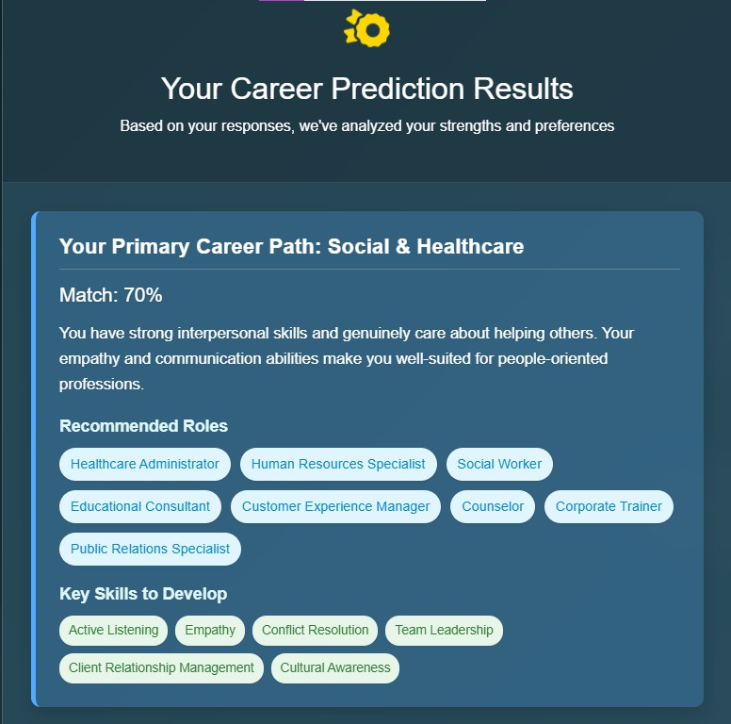

## Logic-Based Evaluation of Responses

Each question in the questionnaire is associated with specific career domains such as creative fields, technical roles, healthcare, business, public services, and more. As the user answers each question, the system assigns scores or flags to one or more career categories based on the selected options.

* + For example, if a user selects answers that indicate strong analytical thinking and a preference for solving problems, the system might increase the score for careers in **engineering**, **data analysis**, or **IT**.
  + If the user’s answers suggest creativity and communication skills, the scores for **design**, **media**, or

**marketing** might be prioritized.

The results are calculated by comparing the total scores or weights associated with each category and selecting the top one or two career paths that best match the user’s response pattern.

## Result Generation Mechanism

Once the questionnaire is completed:

1. All selected answers are stored temporarily using **LocalStorage**.
2. The logic layer (JavaScript) evaluates the stored data using conditions such as:
   * How many times a specific category was favored
   * Which skills or interests were most frequently indicated
   * Priority ranking based on user preferences
3. A final result is generated, typically consisting of:

## A primary career recommendation

* + One or more **alternative suggestions**
  + A brief **description** of each recommended career path

This provides users with clear, concise guidance rather than overwhelming them with multiple unrelated options.

## User-Centric Feedback

The system is designed to offer results that are:

* + **Relevant** – Matching the user’s interests and abilities.
  + **Understandable** – Simple language and direct suggestions.

• **Actionable** – Suggestions that can guide users in making educational or professional decisions.

By keeping the recommendations direct and tailored, the system helps users feel confident in taking their next step toward a career path.

## Performance and Reliability

In user testing and initial trials, the system has demonstrated:

* + **Quick response time**: Results are displayed immediately upon form submission without delays.
  + **Consistent output**: Same inputs always lead to the same suggestions, ensuring logic integrity.
  + **Browser compatibility**: Works smoothly across all major browsers, as it is purely frontend-based.

The rule-based structure ensures that users receive **consistent**, **accurate**, and **predictable** results every time.

# CHALLENGES FACED

Developing the **Career Prediction System** as a **client-side, logic-based web application** presented a diverse set of unique challenges that required both creativity and technical problem-solving. Unlike traditional systems that utilize complex algorithms, server-side programming, or artificial intelligence to make dynamic predictions, this project was deliberately designed to operate entirely within the browser. It relied solely on **core web technologies** such as **HTML, CSS, JavaScript, and Bootstrap**, with no dependency on AI frameworks, cloud databases, or backend scripting. While this approach provided the advantage of simplicity, faster load times, and ease of deployment, it also meant that every aspect of the logic, data processing, user interface, and prediction mechanism had to be carefully structured and executed within the limitations of the front-end environment.

This architecture posed several challenges throughout the development lifecycle, including how to simulate intelligent behavior without AI, how to securely and efficiently store temporary user input without server support, and how to design a UI that would remain functional and visually appealing across a range of devices and screen sizes. Furthermore, ensuring the accuracy of career suggestions through a rule-based scoring model—while keeping the system easy to use and understand—demanded a strategic approach to logic design and user experience. Each phase of the project—from questionnaire design to logic implementation and final deployment—required rigorous planning, multiple iterations, and extensive testing to ensure that the system was both **technically sound and practically useful** for its intended audience.

The following sections provide a comprehensive breakdown of the major challenges faced during this journey and the specific methods, tools, and strategies used to overcome them. These obstacles not only helped shape the project but also significantly contributed to the learning process and overall success of the Career Prediction System.

## Designing Meaningful and Balanced Questions

One of the most critical and intellectually demanding tasks in this project was designing the questionnaire. The entire prediction mechanism depends on the quality and structure of the questions, which means they had to be clear, unbiased, and directly connected to career-relevant traits. Crafting questions that could accurately assess a user’s interests, personality traits, skill preferences, and work styles—while still being simple enough to answer without confusion—was a major hurdle. It was also essential to ensure the balance of options so that no career path would be unfairly weighted. Striking this balance required studying various career guidance frameworks, analyzing multiple sample questionnaires, and iteratively testing different question sets.

* + 🔹 **Solution:**

The questions were refined through repeated feedback loops, sample user testing, and logical mappings to career categories. Each question was linked to one or more domains, and scoring was distributed carefully to ensure fairness and effectiveness in the final career suggestion.

## Mapping Logic Without AI or Backend

Since the system was not built using Artificial Intelligence or machine learning models, implementing intelligent decision-making logic using only plain JavaScript proved to be a significant challenge. The task was to simulate the "smartness" of AI using **conditional statements**, **manual scoring techniques**, and **career categorization logic**. Creating a logic engine that could produce accurate and personalized results— based purely on static rules—required a deep understanding of how career recommendations are typically made by professional counselors or AI-based systems.

* + 🔹 **Solution:**

The challenge was addressed by designing a detailed scoring matrix that linked each answer to specific career domains. JavaScript was used to assign, track, and evaluate these scores in real time. Care was taken to ensure that the logic remained scalable, understandable, and modifiable, should new career fields or questions be added in the future.

## Creating an Intuitive Yet Responsive UI

Designing a user interface that is both visually appealing and functionally intuitive across devices was another major challenge. The Career Prediction System needed to be accessible to users of varying technical backgrounds, particularly students and young individuals. It was important that the UI be easy to navigate, not feel overwhelming, and remain consistent regardless of whether the user accessed it via mobile, tablet, or desktop. Additionally, the design had to align with modern web design standards and offer a pleasant user experience.

* + 🔹 **Solution:**

To overcome this, the Bootstrap framework was used extensively. Its responsive grid system, built- in styles, and pre-defined components allowed the rapid development of a clean and mobile-friendly UI. Design consistency was maintained by using uniform color themes, spacing, and intuitive form layouts. Extra attention was paid to font sizes, button placement, and question layout for clarity and ease of use.

## Storing Data Without a Database

A significant technical limitation of this project was the absence of a backend database or cloud server. Since the system was designed to run entirely on the client-side, it became necessary to find a way to temporarily store user inputs during the session so they could be evaluated after form submission. However, this temporary data storage had to be secure, efficient, and compatible across browsers, without relying on external libraries or tools.

* + 🔹 **Solution:**

To handle this, the built-in **LocalStorage** feature of the browser was utilized. LocalStorage allowed the application to save user-selected answers as key-value pairs that persist even if the user accidentally refreshes the page. This solution offered a lightweight and efficient means of data handling, allowing the scoring algorithm to process all responses after submission without the need for network requests or server calls.

## Debugging and Maintaining Code Consistency

As the logic became more complex, debugging and maintaining clean, readable code became increasingly difficult. Without modularization or a component-based framework, managing numerous variables, event handlers, and DOM manipulations in a single script posed a risk of logic errors and bugs. Additionally, as the questionnaire grew in length and complexity, ensuring the consistency of how answers were stored, processed, and displayed required extra caution.

* + 🔹 **Solution:**

The problem was tackled by writing modular JavaScript code wherever possible and segmenting different tasks into logical functions. Frequent testing at each development stage helped catch and resolve bugs early. Console logging, breakpoints, and condition tracing were used to monitor the flow of data through the system. Clear naming conventions and detailed comments were added to improve readability and future maintenance.

## Hosting and Deployment

Finding a suitable platform for hosting the project, while ensuring that it remained lightweight, fast-loading, and publicly accessible, was another challenge. Since the project did not include backend processing or databases, a static hosting solution was needed. The goal was to allow any user to access the system through a simple URL without requiring installations, logins, or account creation.

* + 🔹 **Solution:**

GitHub Pages was chosen as the deployment platform. It offered a free, stable, and developer- friendly way to publish static websites. The hosting setup was straightforward, and version control through GitHub made updates and bug fixes easy to deploy. This choice allowed the project to be shared widely, tested by others, and demonstrated live for reviews or academic submissions.

# LIMITATION OF THE SYSTEM

While the **Career Prediction System** efficiently provides users with fundamental career recommendations based on a set of predefined rules and client-side logic, it is equally important to recognize and evaluate the various limitations associated with the current implementation. These limitations are primarily a result of the system’s intentionally simplified design, which was created without incorporating advanced computational technologies such as artificial intelligence, dynamic machine learning models, real-time data analysis, or server-side data management.

Since the system operates entirely on the client-side using basic web technologies like **HTML**, **CSS**, **JavaScript**, and **Bootstrap**, it lacks the capacity to perform complex reasoning or learn from user behavior. The absence of server-based logic or AI-powered engines restricts the system from offering deeper personalization or adapting to the evolving needs of individual users. Additionally, the reliance on hardcoded logic means that the system's recommendations are limited to predefined outcomes, making it less flexible and adaptive compared to more intelligent solutions.

Moreover, this simplified setup restricts the system’s ability to integrate live updates from external databases, real-time job market trends, or evolving career fields. It also prevents features like user account creation, result tracking, or longitudinal guidance over time. These constraints, while acceptable for a lightweight, fast-performing prototype, pose significant challenges if the system is to be scaled or used in professional career counseling environments.

Understanding these limitations is crucial for a realistic assessment of the system's current capabilities and forms the basis for identifying areas where the system can be enhanced in future iterations. By examining what the system does not currently support, developers and stakeholders can plan strategic upgrades to improve its accuracy, relevance, and overall usefulness to its users.

## Lack of Personalization through AI or Machine Learning

The system does not employ artificial intelligence or machine learning models to analyze complex patterns in user behavior or preferences. Instead, it uses a static, rule-based logic that maps user answers to predefined career categories. While this approach allows for fast and lightweight performance, it cannot adapt to unique or nuanced user profiles. It lacks the ability to learn from previous user data or refine its recommendations over time. This means the suggestions are only as good as the rules defined in the script and do not account for the individuality that AI-based systems typically offer.

## No Real-Time Data or Industry Trends

Another key limitation is the system's inability to integrate **real-time industry data** such as job market demand, emerging technologies, or current career trends. In a real-world scenario, career guidance often depends on up-to-date labor statistics, evolving job roles, and future employment projections. Since this system functions entirely on the client-side and uses hardcoded logic, it cannot access dynamic information from external sources. As a result, the career suggestions may not always reflect the most relevant or in- demand opportunities in the current job market.

## No User Profile or Progress Tracking

The system does not support the creation of user profiles or history tracking. All user inputs are stored temporarily using **LocalStorage**, which is cleared once the session ends or the user refreshes the page. As a result, there is no way to revisit previous results, compare outcomes over time, or monitor user progress.

This limits the system’s potential as a long-term career planning tool and reduces its effectiveness for users who may wish to revisit or adjust their preferences later.

## Simplified Logic May Not Cover All Career Paths

Although the questionnaire is designed to cover a broad range of interests and personality types, the logic model behind the system is inherently limited. Each answer is mapped to a fixed set of career categories, and the final recommendation is based on a point-scoring mechanism. This method, while functional, does not account for the complexity of overlapping interests, multi-disciplinary skills, or rare career combinations. Users with diverse backgrounds or unconventional aspirations may not find the suggestions entirely suitable.

## Limited Accessibility Features

The system currently lacks some advanced **accessibility features** such as screen reader support, keyboard- only navigation, or adaptive text sizing. This may create usability issues for people with disabilities or special needs. Additionally, there is no option for users to change the language, which could limit adoption among non-English speakers or those unfamiliar with technical vocabulary.

## No Security or Authentication Measures

Because the system does not involve any backend or database, it also lacks **user authentication, data encryption**, or security features. While this is acceptable for a basic prototype or personal use case, it becomes a significant limitation in scenarios where user data privacy and secure handling of responses are required—such as in educational institutions or public deployments.

# FUTURE ENHANCEMENT

Although the current version of the **Career Prediction System** successfully fulfills its primary goal of offering basic career suggestions using client-side technologies, there is significant potential to expand and evolve the system into a more dynamic, intelligent, and versatile platform. These future enhancements aim to overcome existing limitations, improve accuracy, broaden the system's reach, and offer a more personalized and engaging experience for users. Below are some key areas identified for future improvement and advancement:

## Integration of Artificial Intelligence and Machine Learning

One of the most impactful upgrades would be the inclusion of **Artificial Intelligence (AI)** and **Machine Learning (ML)** techniques. By training models on large datasets of student profiles, interests, academic backgrounds, and successful career paths, the system could offer **intelligent, data-driven recommendations** tailored specifically to each user. Unlike the current rule-based logic, an AI-enhanced system could recognize complex patterns in responses, continuously improve through feedback, and adapt its suggestions based on real-world outcomes and user behavior.

## Real-Time Job Market Data Integration

In the future, the system can be enhanced by **connecting to live job market databases or APIs** that provide up-to-date information about current industry demands, trending skills, and emerging career opportunities. This will ensure that the career recommendations are not only relevant to the user's profile but also aligned with market conditions. For example, if demand for data analysts or cybersecurity experts is growing, the system can reflect this in its suggestions, making the advice more practical and timely.

## User Authentication and Progress Tracking

Introducing **user login systems with secure authentication** would allow individuals to create profiles, save their assessment results, and track their progress over time. This would make the platform more useful for long-term career planning and repeat use. Students could return to update their interests or academic status and receive updated recommendations. Additionally, integrating this feature would open up opportunities for analytics and progress dashboards that help users visualize their growth.

## Mobile Application Development

To make the system more accessible and user-friendly across all devices, a **dedicated mobile application**

could be developed using cross-platform frameworks like React Native or Flutter. This would enable users

to take assessments and receive career suggestions on the go, significantly enhancing convenience and user engagement, especially among younger audiences who primarily use mobile devices.

## Multi-Language Support and Localization

Expanding the system to support **multiple languages and regional content** would make it more inclusive and globally accessible. Users from different regions could take the questionnaire in their native languages, and career options could be tailored based on local education systems, employment opportunities, and cultural considerations. This would make the system suitable for deployment in international educational institutions or government career counseling programs.

## Integration with Career Counselors and Mentors

Future versions of the system could include a feature that allows users to **connect with real career counselors or mentors** based on their results. After receiving career recommendations, users could schedule a session with a professional for personalized guidance. This hybrid model would combine the speed and convenience of automation with the depth and empathy of human advice, creating a more holistic career planning experience.

## Educational Pathway Recommendations

In addition to suggesting career options, the enhanced system could provide **roadmaps and educational pathways** needed to reach those careers. For example, if a user is recommended a career in software development, the system could guide them on the necessary qualifications, top universities, online courses, certifications, and internship opportunities. This would help bridge the gap between career interest and actual execution.

## Advanced Analytics and Feedback Loop

To continually improve the system’s effectiveness, a **feedback loop mechanism** could be introduced where users can rate the accuracy of their results, share their real-world experiences, or provide suggestions. This data could be used to fine-tune the logic or retrain AI models, creating a cycle of continuous learning and improvement. Additionally, admin dashboards could provide insights into user demographics, popular careers, and usage trends.

# CONCLUSION

The **Career Prediction System** stands as a practical, user-friendly solution aimed at helping individuals— particularly students—make informed career decisions based on their responses to a structured questionnaire. Developed entirely using client-side technologies such as **HTML**, **CSS**, **JavaScript**, and **Bootstrap**, the system delivers quick and reliable career suggestions without the need for backend infrastructure or third-party libraries. Its simplicity ensures smooth performance across devices, while its accessible design allows users from varied backgrounds to engage with it easily.

The core strength of the system lies in its **logic-based, rule-driven architecture**, which maps user inputs to predefined career categories through a carefully designed scoring mechanism. This ensures that even without AI or complex algorithms, users receive relevant output aligned with their interests, skills, and personal attributes. The intuitive interface, structured questionnaire, and instant result generation contribute to a seamless user experience.

However, the project also highlighted several **key limitations**, such as the absence of personalization through artificial intelligence, lack of dynamic data integration, no user history tracking, and limited scalability. These limitations, while understandable given the project's scope, open the door for **significant future enhancements**. Potential upgrades such as integrating AI/ML technologies, real-time industry data, mobile responsiveness, and multi-language support could transform the system into a more powerful and adaptable career guidance platform.

Overall, this project demonstrates how a lightweight, front-end-based tool can still offer **meaningful career insights** and assist users in taking the first step toward their professional journey. It proves that even with limited resources, impactful digital tools can be built to guide and empower individuals in making critical life decisions. The project not only strengthened technical skills but also emphasized the importance of user- centric design, structured logic, and purposeful functionality. As technology continues to evolve, so too can this system—growing smarter, more responsive, and more beneficial for future users.

# REFRENCES

The **REFRENCES** of my **Career Prediction System** project are mentioned below :-

1. **Mozilla Developer Network (MDN) URL:** [https://developer.mozilla.org](https://developer.mozilla.org/)

**Explanation:** MDN is a trusted source for web development documentation. It was used extensively to understand how to implement HTML, CSS, and JavaScript features accurately. Whether it was DOM manipulation, event handling, or styling techniques, MDN provided in-depth, up-to-date explanations and examples.

## Bootstrap Documentation

**URL:** <https://getbootstrap.com/docs>

**Explanation:** Since Bootstrap was used in this project to speed up UI development, its official documentation helped in integrating responsive layouts, using pre-defined classes for styling, and building components like forms, buttons, and grids efficiently.

## W3Schools

**URL:** [https://www.w3schools.com](https://www.w3schools.com/)

**Explanation:** W3Schools served as a beginner-friendly platform for quickly testing code snippets and learning the syntax of front-end technologies like HTML, CSS, JavaScript, and how to apply them effectively in real-time scenarios.

## GeeksforGeeks

**URL:** <https://www.geeksforgeeks.org/javascript>

**Explanation:** This site provided logic-building examples and problem-solving patterns in JavaScript, which were helpful in designing the questionnaire logic and mapping user responses to career outcomes. It also helped clarify programming concepts during development.

## Stack Overflow

**URL:** [https://stackoverflow.com](https://stackoverflow.com/)

**Explanation:** Stack Overflow was crucial for troubleshooting and debugging issues during

development. Whenever errors or unexpected behaviors occurred in the JavaScript logic or CSS styling, solutions from community discussions proved valuable.

## CSS-Tricks

**URL:** [https://css-tricks.com](https://css-tricks.com/)

**Explanation:** This site offered practical guidance on modern CSS techniques, layout strategies, and visual design improvements. It helped fine-tune the user interface and ensure the design was both functional and aesthetically pleasing.

## GitHub

**Project URL:** <https://kingprince005.github.io/AI-Based-Career-Prediction-System/>

**Explanation:** GitHub hosted the project repository, enabling live deployment and version control. It was also used to manage the source code and ensure updates could be tracked during the project’s development cycle.

## Google Fonts

**URL:** [https://fonts.google.com](https://fonts.google.com/)

**Explanation:** Google Fonts provided clean and modern typography that enhanced the visual appeal of the web application. Custom font integration helped maintain readability and improved the overall user experience.

## Freepik / Unsplash

**URL:** [https://www.freepik.com](https://www.freepik.com/) / [https://unsplash.com](https://unsplash.com/)

**Explanation:** If any images, illustrations, or icons were used in the project, Freepik and Unsplash offered high-quality, royalty-free visual assets to support the content without violating copyright regulations.

## JavaScript Info

**URL:** [https://javascript.info](https://javascript.info/)

**Explanation:** This is a modern and advanced JavaScript tutorial site. It provided deep insights into how JavaScript works behind the scenes. It was helpful for mastering concepts like scope, closures, data handling, and interaction with the browser.

# APPENDIX

This appendix provides additional detailed materials supporting the Career Prediction System project. It includes the full questionnaire used to assess users' preferences and aptitudes, the tools and technologies employed, and other supplementary information.

## Questionnaire (Detailed Questions and Options)

The questionnaire is a vital part of the Career Prediction System. It consists of 10 carefully designed

questions that capture the user’s interests, skills, and work preferences. Each question offers multiple-choice options, represented with icons for better visual appeal.

## Which field excites you the most?

* + Technology & Coding
  + Finance & Investments
  + Marketing & Sales
  + Healthcare & Medicine
  + Engineering
  + Creative & Arts
  + Teaching & Research

## How do you rate your problem-solving skills?

* + Poor
  + Average
  + Good
  + Excellent

## Do you prefer working alone or in a team?

* + Alone
  + In a team
  + Both

## Which work environment suits you best?

• Corporate Office

* + Remote/Freelancing
  + Field Work
  + Creative Work (Design, Media)
  + Technical Lab/Engineering

## How do you handle deadlines?

* + I struggle with deadlines
  + I manage but get stressed
  + I handle them well
  + I thrive under pressure

## What is your biggest passion?

* + Technology & Coding
  + Finance & Data Analysis
  + Helping People (Healthcare, Teaching)
  + Creative Arts & Media
  + Starting My Own Business
  + Sports & Fitness

## Are you comfortable with public speaking?

* + No, I avoid it
  + Sometimes, if necessary
  + Yes, I enjoy speaking to an audience

## Do you enjoy working with numbers and data?

* + Not at all
  + Neutral
  + Yes, I love analyzing data

## How important is creativity in your work?

* + Not important
  + Somewhat important
  + Very important

## How do you handle stress?

* + I struggle with stress
  + I manage but feel overwhelmed
  + I handle stress well

## Tools and Technologies Used

* + **Languages:** HTML5, CSS3, JavaScript (Vanilla)
  + **Framework:** Bootstrap 5 for responsive and faster UI development
  + **Storage:** LocalStorage for temporarily storing user responses on the client side
  + **Hosting:** GitHub Pages for easy and free deployment
  + **Icons:** FontAwesome icons integrated for visual representation of options

## Flow Diagram

(Attach or insert your flow diagram here illustrating the user journey from the landing page through the questionnaire, logic-based processing of responses, and the final career prediction output.)

## Screenshots of the Application

* + Home Page with introduction
  + Questionnaire interface displaying question and options
  + Result page showing career recommendation
  + Mobile responsive view

## Sample Output User Input Example:

* + Excited by: Technology & Coding
  + Problem-solving skills: Excellent
  + Work preference: Both alone and team
  + Work environment: Technical Lab
  + Deadline management: Thrive under pressure
  + Passion: Entrepreneurship
  + Public speaking: Yes, enjoys it
  + Enjoys data: Loves it
  + Creativity importance: Very important
  + Stress handling: Manages well

## Predicted Career Path:

*“Based on your interests and skills, a career in Technology, Software Engineering, or Entrepreneurial ventures in the tech field would be well suited for you.”*

## Project Repository

* + **Live Project URL:** <https://kingprince005.github.io/AI-Based-Career-Prediction-System/>
  + **GitHub Source Code:** (Add link to your GitHub repo if separate)